**PROJECT REPORT**

**ON**

**Bookmydoc**

Submitted in the partial fulfillment of requirement

For the award of degree in

**Master Of Science**

**(Information Technology And Computer Application)**



**SAURASHTRA UNIVERSITY - RAJKOT**

**BY**

**Nayan Bharada**

**Under the guidance of:**

**Internal Guide:**

**Prof. Ram Kevalramani**

**VIDYASAGAR INFOTECH COLLEGE**

**[Affiliated To Saurashtra University - Rajkot]**

**“Silver plaza”, 7 patel colony, Nr. Deep Bhavan,**

**Jamnagar -361008.**

**Email:** [vsiinfocollege@gmail.com](mailto:vsiinfocollege@gmail.com) **URL: www.vsicollege.info**

**STUDENT PROFILE**

|  |  |
| --- | --- |
| **Enrollment Number:** | **0031081843** |
| **Name:** | **NAYAN V.BHARADA** |
| **Stream:** | **M.Sc.(IT & CA)** |
| **Semester :** | **SEM-4** |
| **Address:** | **BHAGVATI SOCITY SIKKA JAMNAGAR** |
| **Contact No.:** | **8758162943** |
| **E-mail:** | [Bharadanayan47@gmail.com](mailto:Bharadanayan47@gmail.com) |

**PROJECT PROFILE**

|  |  |
| --- | --- |
| **Project Title :** | Bookmydoc |
| **Definition Of Application :** | This project is to help people to find doctor and hospitals where they can find their specialist doctor and hospital also able book appointment as per the available date and time slot.  Where doctors and hospitals can register with this portal and provide their service to their clients. |
| **Developed At :** | Vidhyasagar InfoTech College Jamnagar |
| **Developed For :** | Bookmydoc |
| **Team Size :** | 1 |
| **Team Member Name :** | Nayan Bharada |
| **Internal Project Guide :** | Prof. Ram Kevalramani |
| **Platform :** | Linux |
| **Documentation Tools :** | LibreOffice, draw.io |
| **Front End :** | Python(Django) |
| **Back End:** | MySQL |

**PROJECT GUIDE PROFILE**

|  |  |
| --- | --- |
| **Guide Name :** | Prof. Ram Kevalramani |
| **Contact No. :** | **9824872679** |
| **E-mail :** | ramsirforstudents@gmail.com |

**ACKNOWLEDGEMENT**

**This project is developed in 2020 to consider the requirement of Bookmydoc.**

**I am also thankful to our College, Trustees, Principal, Professors, Teaching and Non-Teaching Staff and Colleagues who have helped and guided us in preparing this project.**

**I am also thankful to Wikipedia encyclopedia the Internet Online library to guide me to develop the project report.**

**Yours Faithfully,**

**NayanBharada**

**Place: Jamnagar**

**Date:**

**ABSTRACT**

The purpose of bookmydoc is to automate the existing manual system by the help of computerized equipment’s and full-fledged computer software, fulfilling their requirements, so that their valuable data/information can be stored for a longer period with easy accessing and manipulation of the same.

* **AIM OF PROJECT**

Project making is a part of M.Sc.(IT & CA) Sem-4 the student gets a chance to have practical knowledge of the software exposure as to gain control over programming languages. The objective of practical training of M.Sc.(IT & CA) Sem-4 levels is to develop among the students a feeling of software making in order to develop a practical base in them as supplement to the theoretical study of the computer application in general.

Such project making plays a dominant role in developing practical view points, experience and also make them aware about the role situation of the software application.

This project is prepared under my knowledge, guidance given by our professors and especially Thanks to concerned person, who has helped us to get knowledge on the project.

* **PROJECT CATEGORY**

This project is a **Web base** project. This is an RDBMS based project which is currently using MySQL for all the transaction statements. MySQL is an opensource RDBMS System.

**PROJECT DESCRIPTION**

The current standard operating procedure in healthcare environment for patient registration and appointment scheduling are time consuming and somehow troublesome.

Bookmydoc is a web-based application developed for managing appointment-booking process for a few medical organizations.

The Bookmydoc in 4 type of actor. (1) Patient (2) Hospital (3) Doctor (4) Superuser. If you registered first than after login default user will be patient. Patient can book a doctor appointment by given time slot. And their appointment can be see the doctor. After login patient can see their profile and insert medical history.

The second actor is hospital. Hospital can send request to admin pannel. Superuser can approved than hospital/clinic will automatic registered as hospital. Registerd hospital can add doctor & manage hospital profile. Also Booked appointment.

The third actor is doctor. Doctor login after edit profile and add qualification. Doctor can add their time slot on weekly bases. Doctor can see today appointments and all other appointments. Doctor can also see the medical history of registered patients. Doctor can also manage patient check-in time and patient check-out time.

The fourth actor is superuser. Superuser is manage whole application. Superuser is mange hospital, appointments,doctors, patients.

By developing this system, it will reduce the number of calls for an appointment and avoid the morning rush for an urgent appointment. Also, it will potentially reduce the need for extra reception staff, a significant reduction in labor. Furthermore, it helps user in time saving and avoiding the need to negotiate with the receptionist for a convenient appointment time. This technology can transform the current daunting appointment process and enable them to run more efficiently, effectively and profitably.

**INDEX**

|  |  |  |
| --- | --- | --- |
| 1. | Introduction   * Project Summary * Purpose * Scope * Technology & Literature Review | 14 |
| 2. | Project Management   * Project Planning * Risk Management System | 16 |
| 3. | Python   * Features Of Python * Django | 20 |
| 4. | System Requirement Study   * User Characteristics and Software * Hardware and Software Requirements | 28 |
| 5. | System Analysis   * Study of Current System * Problem and Weakness of Current System * Requirement and New System * Feasibility Study | 30 |
| 6. | System Design   * Data Flow Diagram * Data Dictionary * Entity Relationship Diagram * Use Case | 35 |
| 7. | Implementation and Planning Details   * Implementation and Environment * Project Modules Specification * Coding Standards | 49 |
| 8. | Testing   * Testing Methods * Testing Cases | 54 |
| 9. | Screen Shot and User Manuals   * Screen Shot * User Manual | 64 |
| 10. | Limitation & Future Enhancement   * Limitation * Future Enhancement | 79 |
| 11. | References | 80 |

**Introduction**

The main objective of the project on bookmydoc is manage the details of doctor, appointment, patient, booking, doctor schedule. it manage all the information about doctor.

## PURPOSE OF PROJECT:-

If anybody is ill and wants to visit a doctor for checkup, he or she needs to visit the hospital and waits until the doctor is available. The patient also waits in a queue while getting appointment. If the doctor cancels the appointment for some emergency reasons then the patient is not able to know about the cancellation of the appointment unless or until he or she visits the hospital.

The purpose of the project is to build an application program to reduce manual work for managing the doctor, appointment, patient. It track all the detail about patient, booking.

#### SCOPE OF PROJECT:-

It may help collecting perfect management in detail. In a very short time. breaking a problem into successively manageable parts for individual study. Every application development project should begin with an analysis of the requirements and clear list of goals. The basic aim of analysis is to obtain a clear understanding of user’s needs & what exactly is desired from the software, and what constraints on the solution are.

* **SOFTWARE USED:-**

1. Pycharm
2. Python
3. LibreOffice
4. Snagit

**PROJECT MANAGEMENT**

The manager who forgets that software engineering work is an intensely human endeavor will never have success in project management.

A manager who fails to encourage comprehensive customer communication early in the evolution of a project risks building an elegant solution for the wrong problem.

Finally the manager who pays little attention to the process runs the risks of inserting competent technical methods & tools into a vacuum.

Project Management has two parts like:

* Project Planning & Scheduling
* Risk Management
* **PROJECT PLANING AND SCHEDULING:-**

The software project management process begins with a set of activities that are collectively called Project Planning.

The first of these activities is Estimation. Whenever estimates are made, we look into the future and accept some degree of uncertainly as a matter of course. Although estimating is as much art as it is science, this important activity need not be conducted in a random manner. Useful techniques for time & effort estimation do exist. And because estimation lays a foundation for all other project planning activities, and project planning provides the road map or successful software-engineering.

Software project plan can be viewed as the following:

**1) Within the organization**: How the project is to be implemented? What are various constraints (time, cost, staff)? What is market strategy?.

**2) With respect to the customer:** Weekly or timely meetings with the customer with presentation on status reports. Customers feedback is also taken and further modification and developments are done. Project milestones and deliverables are also presented to the customer.

**Project Planning Objectives:**

1. Software Scope
2. Resources

**RISK MANAGEMENT:-**

Although there has been considerable debar about the proper definition for software risk, There is general agreement that risk always involves two characteristics:

**Uncertainly: -**

The events that characterize the risk may or may not happen.

i.e. There are not 100% probable risk.

**Loss: -**

If the risk becomes a reality unwanted consequences or loses will occur. When risks analyzed it is important to quantify the level of uncertainly and the degree of loss associated with each risk. To accomplish this, different categories of risk are considered.

**Category of Risk:**

1) Project Risk

2) Technical Risk

3) Business Risk

**Types of Risk:**

1) Product Size Risk

2) Business Impact Risk

3) Customer Related Risk

4) Process Risk

5) Process Issues

6) Technical Issues

7) Technology Risk

**Python**

* **Introduction :-**

Python is an object-oriented, high level language, interpreted, dynamic and multipurpose programming language.

Python is easy to learn yet powerful and versatile scripting language which makes it attractive for Application Development.

Python's syntax and dynamic typing with its interpreted nature, make it an ideal language for scripting and rapid application development in many areas.

Python supports multiple programming pattern, including object oriented programming, imperative and functional programming or procedural styles.

Python is not intended to work on special area such as web programming. That is why it is known as multipurpose because it can be used with web, enterprise, 3D CAD etc.

We don't need to use data types to declare variable because it is dynamically typed so we can write a=10 to declare an integer value in a variable.

Python makes the development and debugging fast because there is no compilation step included in python development and edit-test-debug cycle is very fast.

* **Features Of Python :-**

There are a lot of features provided by python programming language.

**1) Easy to Use:**-

Python is easy to very easy to use and high level language. Thus it is programmer-friendly language.

**2) Expressive Language:-**

Python language is more expressive. The sense of expressive is the code is easily understandable.

**3) Interpreted Language:-**

Python is an interpreted language i.e. interpreter executes the code line by line at a time. This makes debugging easy and thus suitable for beginners.

**4) Cross-platform language:-**

Python can run equally on different platforms such as Windows, Linux, Unix, Macintosh etc. Thus, Python is a portable language.

**5) Free and Open Source:-**

Python language is freely available(www.python.org).The source-code is also available. Therefore it is open source.

**6) Object-Oriented language:-**

Python supports object oriented language. Concept of classes and objects comes into existence.

**7) Extensible:-**

It implies that other languages such as C/C++ can be used to compile the code and thus it can be used further in your python code.

**8) Large Standard Library:-**

Python has a large and broad library.

**9) GUI Programming:-**

Graphical user interfaces can be developed using Python.

* **Introduction Of Django :-**

Django is a free and open source web framework for Python. After its first release in 2005, it became more and more popular among Python programmers as the de-factor framework for web development. Django emphasizes reusability and pluggability of components so that distinctive pieces of code can be plug-n-played together to form a cohesive web system.

Another principle promoted by Django is DRY (Don't Repeat Yourself). DRY aims at reducing repetitive pieces of information of all kinds in software development. For example, instead of writing the server's static folder as a raw string everywhere in the code, we should assign the static folder's address to a constant defined in the application's settings file so that we can easily change it in the future.

Besides providing libraries for common web tasks such as database interaction and session management, Django also provides an built-in admin site that allows programmers and administrators of the web site to easily create, read, update and delete database records from a GUI interface.

Django is a high-level Python Web framework that encourages rapid development and clean, pragmatic design. Built by experienced developers, it takes care of much of the hassle of Web development, so you can focus on writing your app without needing to reinvent the wheel. It’s free and open source.

Django makes it easier to build better Web apps more quickly and with less code.

* **Features Of Django:-**

What makes Django a heavy hitter among web developers? Its **modularity** is a major selling point. Django’s major features are all meant to be decoupled, allowing the developers to pick and choose which pieces of functionality are right for their project. The result is more streamlined code and improved performance.

Django also has a lot of **transparency** over competitors like [Ruby on Rails](https://www.upwork.com/hiring/development/ruby-developer/), which runs more scripts behind the scenes. Django’s lack of “magic” means you can run a project-wide search and always find the code you’re looking for. It’s less opinionated and more declarative, which in the end will be a developer’s preference.

Here are a few of the major features that make it well suited to quickly developing web apps:

**A free, rich API.** With a simple command, Django automatically generates a Python API based on your models, no additional coding necessary.

**Automatic database table creation.** The migrate command is an elegant and distinctive feature of Django that looks at all your models and automatically creates tables in your database for any that don’t exist already.

**A dynamic admin interface generator.** The idea here is that, rather than requiring you to build out an entire website before you can start populating it with information, Django makes it quick and easy to set up the admin site, which allows contributors to start populating the database while the developers figure out how to display that content.

**A syndication feed framework.** Django also allows you to quickly and easily create RSS and Atom feeds by creating a simple Python class. These feeds can be simple (eg, a typical news feed of latest posts) or more specialized (eg, all posts in a given category or that feature a certain keyword).

**A powerful cache framework for dynamic websites.** This system lets you cut down on expensive calculations by caching dynamic pages. There are a few levels of granularity here: You can cache individual pages or just the most expensive views to produce.

**A powerful built-in template system.** Django’s templates are based on the inheritance system (similar to [object-oriented programming](https://www.upwork.com/hiring/development/object-oriented-programming/)). These templates allow Django to generate HTML dynamically while also eliminating redundancies.

**Easy database migrations.** Managing database workflow with Django’s migrations is simple and streamlined. Version control is managed through migration names, and Django has lots of options for merging versions or letting developers make modifications.

**Security features.** Django has tools to protect against XSS attacks, CSRF attacks, SQL injections, clickjacking, and more. It also allows you to easily enable SSL/HTTPS and host header validation.

**Other helpful add-ons.** Bundled add-ons include sitemaps, comments, user authentication, RSS feeds, and more. By including many of these standard features out-of-the-box, web developers can focus on the genuinely hard parts rather than recreating standard functionality from scratch.

**SYSTEM REQUIREMENT**

It Studies the current business system to find out how it works and where improvement should be made? This study consider both manual and computer methods.

A requirement is a feature that must be include in a new system it may include a way of capturing or processing data, producing information, controlling a business activities or supporting management.

* **CHARACTERISTIC OF SOFTWARE:-**

1) Predetermine objectives

2) Set of Component

3) Set of Process

4) Inter related and Interdependence

5) Sub System

6) Integration

* **SOFTWARE REQUIREMENTS:-**

|  |  |
| --- | --- |
| **Name of component** | **Specification** |
| Operating system's | Any of Windows 98, Windows XP, Windows 7, Linux, etc |
| Language | Python |
| Browser | Any of Mozilla, Opera, Chrome etc |
| Services required | Django (front-end)  MySQL(back-end) |

* **HARDWARE REQUIREMENTS:-**

|  |  |
| --- | --- |
| **Name of component** | **Specification** |
| Processor | Intel core processor |
| Ram | 4 GB RAM |
| Hard disk | 500 GB |

**SYSTEM ANALYSIS**

System analysis is a process of gathering and interpreting facts, diagnosing problems and the information about the Bookmydoc to recommend improvements on the system. It is a problem solving activity that requires intensive communication between system user and system developers. System analysis or study is an important phase of any system development process. The system is studied to the minutest detail and analyzed. The system analyst plays the role of the interrogator and dwells deep into the working of the present system.

* **STUDY OF CURRENT SYSTEM:-**

We have done detailed study about the existing system and we found following fact. All the works such as administration maintenance ware performing manually. Some services were computerized but they have not proper and complete website for maintenance their works.

We find that there was a need of computerized system to maintain that works.

* **Problem & Weakness of Current System:-**

The Preliminary Investigation starts as soon as someone either a user or a member of a particular department recognizes a problem or initiates a request, to modify the current computerized system, or to computerize the current manual system. An important outcome of the preliminary investigation is determining whether the system requested is feasible or not.

The major purposes of this study are listed below:

* **Requirement of New System:-**

**There are two specific groups of end-users:**

Those who uses the system. In this case the End-Users and Officer who actually comes in control activity.

Those affected by the inputs and outputs of the system in study. In this case the management who decides the schemes given to user, the slip amount taken from the staff is involved.

To develop the initial scope of the system we need to get a broad idea of the system in study. In this case we can identify the main process as ‘to get the details of the Staff, Trainee and other aspects’, which gets the input from each fault maker. The output of the system is also sent back to the respective staff and branch Office.

* **Feasibility Study:-**

Feasibility is the determination of whether or not a project is worth doing. The process followed in making this determination is called a feasibility study. This type of study determines if a project can and should be taken. Once it has been determine that project is feasible, the analyst can go ahead and prepare a project specification, which finalizes project requirements.

In the conduct of the feasibility study, we usually consider seven distinct, but inter-related types of feasibility. They are:

* + - * 1. Technical Feasibility
        2. Economical Feasibility
        3. Operational Feasibility
* **Technical Feasibility:-**

The Technical needs of the system are as follows:

* + 1. Facility to communicate data to distant location.
    2. Response time under certain conditions.
    3. Ability to process a certain volume of transaction at a particular speed.

In examining the technical feasibility, configuration is given more importance than actual make of hardware. Here the configuration gives the complete picture about the system’s requirements:

* How many workstations are required?
* How these workstations are interconnected so that they can operate and communicate smoothly.
* What speeds of Input and Output should be achieved.

As the above requirements of the system can be fulfilled easily with the technology available in the market, therefore the proposed system is technically feasible.

* **Economical Feasibility:-**

Economic analysis is the most frequently used technique for evaluating the effectiveness of a proposed system. More commonly known as Cost/Benefit analysis; the procedure is to determine the benefits and savings that are expected from a proposed system and compare them with the costs. If benefits outweigh costs, a decision is taken to design and implement the system. Otherwise, further justification or alternative in the proposed system will have to be made if it is to have a chance of being approved.

Proposed system for Bookmydocis economically feasible in terms of time and effort of staff and management. Cost will be incurred at the beginning but the effort and time saved by the proposed system far outweighs the cost incurred. Since the classes is not already computerized, so initially large amount will be involved but in due course with the outcome of the system, the cost will be outweighed by the result of the automated system.

* **Operational Feasibility**

It is mainly related to human company and political aspects. The points to be considered are:

* + 1. What changes will be brought with the system?
    2. What company structures are distributed?
    3. What new skills will be required?

**SYSTEM DESIGN**

**Data Flow Diagram:**

**0 LEVEL DFD:-**

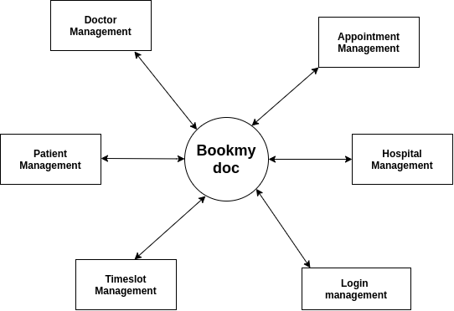

**1st LEVEL DFD:-**

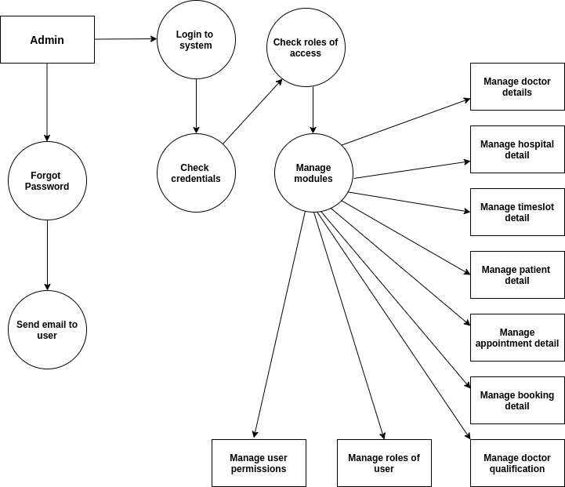

**USE CASE**

**Superuser:-**

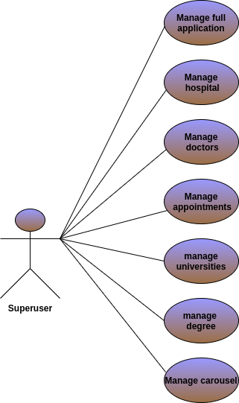

**Patient:-**

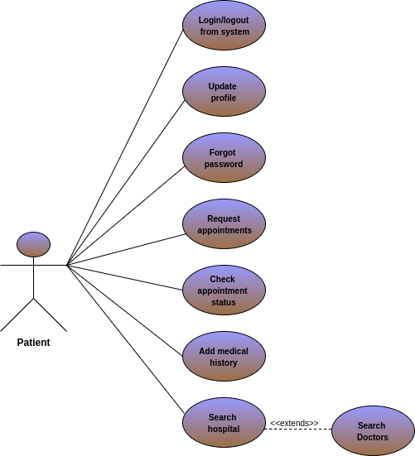

**Doctor:-**

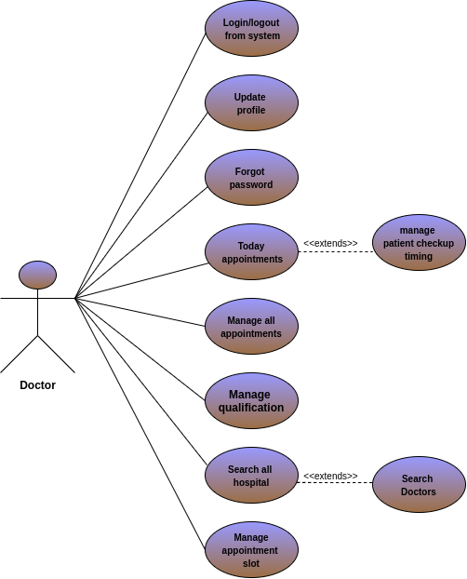

**Hospital:-**

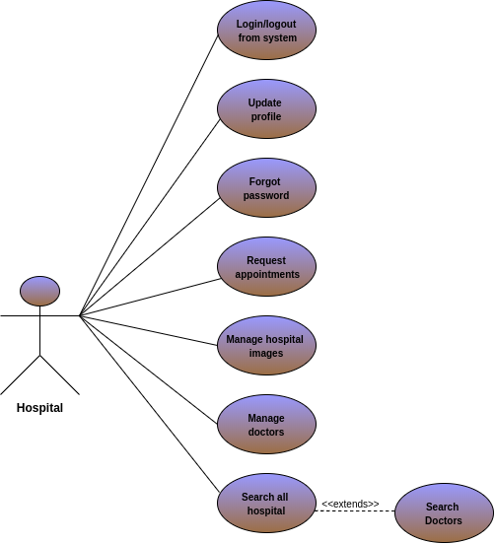

**EER(enhanced entity–relationship )**

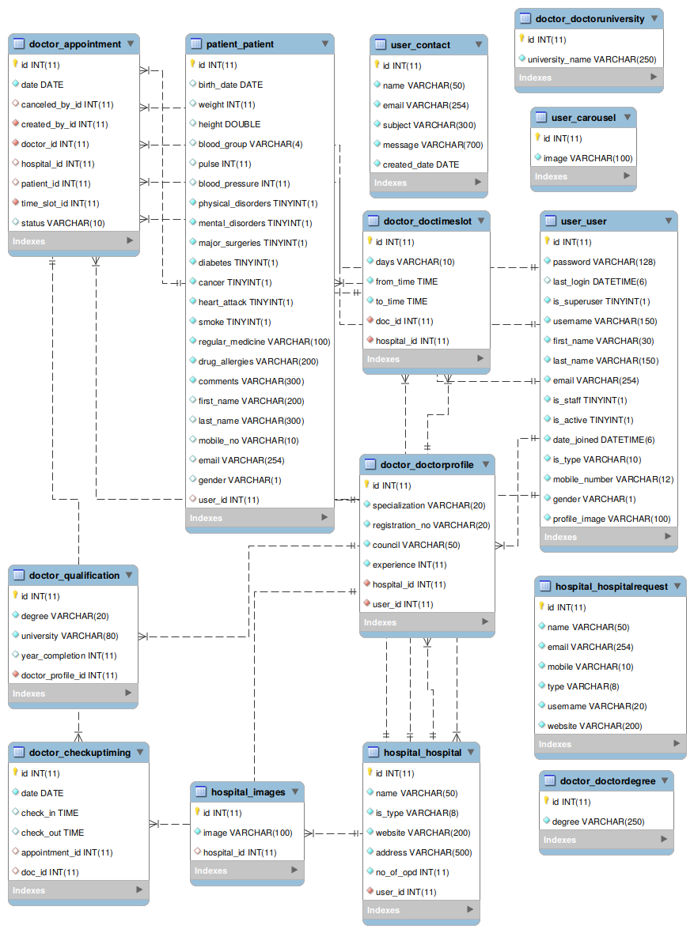

**Gannt Chart**

|  |  |  |  |  |  |  |  |  |  |  |  |  |  |  |  |  |  |
| --- | --- | --- | --- | --- | --- | --- | --- | --- | --- | --- | --- | --- | --- | --- | --- | --- | --- |
| **Month** | **1-31 Dec** | | | | **1-31 Jan** | | | | **1-29 Feb** | | | | **1-31 Mar** | | | | |
| **Weeks** | **1** | **2** | **3** | **4** | **1** | **2** | **3** | **4** | **1** | **2** | **3** | **4** | **1** | **2** | | **3** |  |
| **Tasks** |  | | | | | | | | | | | | | | | | |
| **Understanding**  **The System** |  |  |  |  |  |  |  |  |  |  |  |  |  |  |  | |  |
| **Analysis Of**  **Requirements** |  |  |  |  |  |  |  |  |  |  |  |  |  |  |  | |  |
| **Database And**  **GUI Designing** |  |  |  |  |  |  |  |  |  |  |  |  |  |  |  | |  |
| **Coding And**  **Testing** |  |  |  |  |  |  |  |  |  |  |  |  |  |  |  | |  |
| **Final Documentation** |  |  |  |  |  |  |  |  |  |  |  |  |  |  |  | |  |
| **Learning**  **Process** |  |  |  |  |  |  |  |  |  |  |  |  |  |  |  | |  |

Data Dictionary

**Doctor_Appointment:**

|  |  |  |  |
| --- | --- | --- | --- |
| **Column** | **Type** | **Null** | **Description** |
| Id*(Primary)* | Int(11) | No | Unique id of doctor_appointment |
| Date | Date | No | Date of doctor_appointment |
| Canceled_by_id | Int(11) | Yes | Reference of user |
| Created_by_id | Int(11) | No | Reference of user |
| Doctor_id | Int(11) | No | Reference of doctor_profile |
| Hospital_id | Int(11) | Yes | Reference of hospital |
| Patient_id | Int(11) | Yes | Reference of patient |
| Time_slot_id | int(11) | No | Reference of doctor_timeslot |
| Status | Varchar(10) | Yes | Status of doctor_appointment |

**Doctor_checkuptiming:**

|  |  |  |  |
| --- | --- | --- | --- |
| **Column** | **Type** | **Null** | **Description** |
| Id*(Primary)* | Int(11) | No | Unique id of doctor_checkuptiming |
| Date | Date | No | Date of doctor_checkuptiming |
| Check_in | Time | Yes | Check_in of doctor_checkuptiming |
| Check_out | Time | Yes | Check_out of doctor_checkuptiming |
| Appointment_id | Int(11) | No | Reference of doctor_appointment |
| Doc_id | Int(11) | Yes | Reference of doctor_profile |

**Doctor_timeslot:**

|  |  |  |  |
| --- | --- | --- | --- |
| **Column** | **Type** | **Null** | **Description** |
| Id*(Primary)* | Int(11) | No | Unique id of doctor_timeslot |
| Days | Varchar(10) | No | Days of doctor_timeslot |
| From_time | Time | No | From_time of doctor_timeslot |
| To_time | Time | No | To_time of doctor_timeslot |
| Doc_id | Int(11) | No | Reference of doctor |
| Hospital_id | Int(11) | No | Reference of hospital |

**Doctor degree:**

|  |  |  |  |
| --- | --- | --- | --- |
| **Column** | **Type** | **Null** | **Description** |
| Id*(Primary)* | Int(11) | No | Unique id of doctor_degree |
| Degree | Varchar(250) | No | Degree of doctor_degree |

**Doctor profile:**

|  |  |  |  |
| --- | --- | --- | --- |
| **Column** | **Type** | **Null** | **Description** |
| Id*(Primary)* | Int(11) | No | Unique id of doctor_profile |
| Specialization | Varchar(20) | No | Specialization of doctor_profile |
| Registration_no | Varchar(20) | No | Registration_no of doctor_profile |
| Council | Varchar(50) | No | Council of doc_profile |
| Experience | Int(11) | No | Experience of doctor_profile |
| Hospital_id | Int(11) | No | Reference of hospital |
| User_id | Int(11) | No | Reference of user |

**Doctor university:**

|  |  |  |  |
| --- | --- | --- | --- |
| **Column** | **Type** | **Null** | **Description** |
| Id*(Primary)* | Int(11) | No | Unique id of doctor_university |
| University_name | Varchar(250) | No | Unique university of doctor_university |

**Doctor_Qualification:**

|  |  |  |  |
| --- | --- | --- | --- |
| **Column** | **Type** | **Null** | **Description** |
| Id*(Primary)* | Int(11) | No | Unique id of doctor_qualification |
| Degree | Varchar(20) | No | Degree of doctor_qualification |
| University | Varchar(80) | No | University of doctor_qualification |
| Year_completion | Int(11) | Yes | Year_completion of doc_qualification |
| Doctor_profile_id | Int(11) | No | Reference of doctorprofile |

**Hospital:**

|  |  |  |  |
| --- | --- | --- | --- |
| **Column** | **Type** | **Null** | **Description** |
| Id*(Primary)* | Int(11) | No | Unique id of hospital |
| Name | Varchar(50) | No | Name of hospital |
| Is_type | Varchar(8) | No | Type of hospital |
| Website | Varchar(200) | No | Website of hospital |
| Address | Varchar(500) | No | Address of hospital |
| No_of_opd | Int(11) | No | No_of_opd in hospital |
| User_id | Int(11) | No | Reference of user |

**Hospital request:**

|  |  |  |  |
| --- | --- | --- | --- |
| **Column** | **Type** | **Null** | **Description** |
| Id*(Primary)* | Int(11) | No | Unique id of hospital_request |
| Name | Varchar(50) | No | Name of hospital |
| Email | Varchar(254) | No | Email of hospital |
| Mobile | Varchar(10) | No | Mobile of hospital |
| Type | Varchar(8) | No | Type of hospital |
| Website | Varchar(200) | No | Website of hospital |

**Hospital_image:**

|  |  |  |  |
| --- | --- | --- | --- |
| **Column** | **Type** | **Null** | **Description** |
| Id*(Primary)* | Int(11) | No | Unique id of hospital_image |
| Image | Varchar(100) | No | Image of hospital |
| Hospital_id | Int(11) | Yes | Reference of hospital |

**Patient:**

|  |  |  |  |
| --- | --- | --- | --- |
| **Column** | **Type** | **Null** | **Description** |
| Id*(Primary)* | Int(11) | No | Unique id of patient |
| Birth_date | Date() | Yes | Birthdate of patient |
| Weight | Int(11) | Yes | Weight of patient |
| Height | Double | Yes | Height of patient |
| Blood_group | Varchar(4) | Yes | Blood_group of patient |
| Pulse | Int(11) | Yes | Pulse of patient |
| Blood_pressure | Int(11) | Yes | Blood_pressure of patient |
| Physical_disorders | Int(1) | No | Physical_disorders or not |
| Mental_disorders | Int(1) | No | Mental_disorders or not |
| Major_surgeries | Int(1) | No | Major_surgeries or not |
| Diabetes | Int(1) | No | Diabetes or not |
| Cancer | Int(1) | No | Cancer or not |
| Heart_attack | Int(1) | No | Heart_attack or not |
| Smoke | Int(1) | No | Smoke or not |
| Regular_medicine | Varchar(100) | Yes | Regular_medicine of patient |
| Drug_allergies | Varchar(200) | Yes | Drug_allergies of patient |
| Comments | Varchar(300) | Yes | Comments of patient |
| First_name | Varchar(200) | Yes | First_name of patient |
| Last_name | Varchar(300) | Yes | Last_name of patient |
| Mobile_no | Varchar(10) | Yes | Mobile_no of patient |
| Email | Varchar(254) | Yes | Email of patient |
| Gender | Varchar(1) | Yes | Gender of patient |
| User_id | Int(11) | No | Reference of User |

**Carousel:**

|  |  |  |  |
| --- | --- | --- | --- |
| **Column** | **Type** | **Null** | **Description** |
| Id*(Primary)* | int(11) | No | Unique id of carousel |
| Image | Varchar(100) | No | Image of carousel |

**Contact:**

|  |  |  |  |
| --- | --- | --- | --- |
| **Column** | **Type** | **Null** | **Description** |
| Id*(Primary)* | int(11) | No | Unique id of contact |
| Name | Varchar(50) | No | Name of contact |
| Email | Varchar(254) | No | Email of contact |
| Subject | Varchar(300) | No | Subject of contact |
| Message | Varchar(700) | No | Message of contact |
| Created_date | Date() | No | Created date of contact |

**User:**

|  |  |  |  |
| --- | --- | --- | --- |
| **Column** | **Type** | **Null** | **Description** |
| Id*(Primary)* | int(11) | No | Unique id of user |
| Password | Varchar(128) | yes | Password of user |
| Last_login | Datetime(6) | yes | Last_login of user |
| Is_superuser | Int(1) | No | Is_superuser or not |
| Username | Varchar(150) | No | Unique username of user |
| First_name | Varchar(30) | No | Firstname of user |
| Last_name | Varchar(150) | No | Lastname of user |
| email | Varchar(254) | No | Unique email of user |
| Is_staff | Int(1) | No | Is_staff or not |
| Is_active | Int(1) | No | Is_active or not |
| Date_joined | Datetime(6) | No | Date_joined of user |
| Is_type | Varchar(10) | No | Type of user |
| Mobile_number | Varchar(12) | No | Mobile_number of user |
| Gender | Varchar(1) | No | Gender of user |
| Profile_image | Varchar(100) | No | Profile_image of user |

**IMPLEMENTATION AND PLANNING DETAILS**

* **IMPLEMENTATION AND ENVIRONMENT**

Implementation is a phase where a number of activities that have been going on parallel so far have to culminate. To ensure that all these activities indeed converge at the right time and at the right place without any delays on account of unforeseen problems, to get the software to be used at is should, is what managing the implementation phase is all about. the steps involved are:

**Installation Plan:** Much before the software could be actually ready; a detailed plan has to be prepared in terms of hardware, procurement and installation. What machines are to be installed at which location and at what point in time, provision of the necessary infrastructure for installation of the same, site preparation, arranging any machines specific or commodity software specific training for different categories of users etc. are details which would need to be worked out. Likewise a plan has got to be mad for installation of the software to be implemented. Details of which modules are to be Enabled/Disabled in each location have to be worked out. Therefore a comprehensive installation plan needs to be in place, which gives location wise installation details as relevant to different user groups. So, for Bookmydoc an implementation plan was prepared at the right time.

**Data Preparation and Conversion:** Assuming that the system is expected to go live from a particular date, all backlogs of data has to be transcribed to fit into the new formats and coding schemes and rigorously errors are checked to ensure no loss of information.

For Bookmydoc all the existing REGARDING works and others was fed into the system, as the details of the Bookmydoc is to be maintained old records new also apart from the fresh data is displayed in the Heading.

**Conversion Testing:** Where data is converted from existing files or databases, rigorous conversion testing needs to be done to ensure proper conversion.

The following steps testing were performed as a part of conversion for “Bookmydoc”.

Tallying of input and output record.

Extraction of sample records from both the old and new set of records. This are then directly compared with each other.

Check value ranges of fields within each record.

Check whether the required relationships between records are maintained.

**User Training:** The successful implementation of any website is depend in good measure on the quality of training imparted. Different user groups need to be identified. A training need analysis has to be done for each of these groups to find out what kind of training is required for each. Getting trained on aspects that are not relevant may sometimes tend to confuse the users.

**Security Measures Taken:** Security and controls are required not only for preventing in inadvertent mistakes made by users, but also to prevent misuse of the system and ensure data integrity.

In an automated system Bookmydoc website the following security measures have been considered:

* **PROJECT MODULE OF NEW SYSTEM:-**
* User
* Doctors
* Hospital
* Patient
* Appointment -time slot
* Contacts
* Qualification
* Checkup-timing
* **CODING STANDARD:-**

**Access Control:**

The Access Control can be defined as control established to ensure that only administrator is accessed with the proper authority. Different types of access control, which are used in this software, are as follows:

**Physical Access:-**

The best form of access control is the physical access control. Only authorized person should be allowed to do specific tasks like Hospital Request Approved, Slider Panel, etc.

**Validations:-**

Validations of data entered on various input screens are not a security for the system but a control to ensure that clean data goes into the system. If data is not validated on input, you will end up with a lot of inconsistent data.

**Length of Data:-**

Type of data (numeric, integers, alphabetic, alphanumeric), Discreet values, Cross validation of data across various fields.

**Data Integrity:-**

We can have the best of validation in a system but invalid data can always get into the system due to some recent changes done on the website, which was not tested comprehensively, of due to corruption.

**Security Features:-**

In the Bookmydoc we have set the best security feature to operate the application, when user logged into the websites ask for the username and password which are stored into a database & it will check both username & password condition, if user do any mistake to entering the username and password then application will count the wrong username and password which is entered by user when user logged into website it will display to the user that how many times the wrong username and password are entered this system called **“Hack Detector”.**

**Testing**

### The word “test” is derived from the Latin word “tested” meaning pottery vessel used to measure and access weight. The testing of software is a means of accessing or measuring the software to determine its quality. Testing is done with one primary objective- to ensure the quality of software before live operations. Testing involves operation of a system or application under controlled conditions and evaluating the results. In the development of automated system for Bookmydoc, we have applied the following testing techniques and testing Strategies.

* **Testing Plan:-**
* **White - Box Testing**

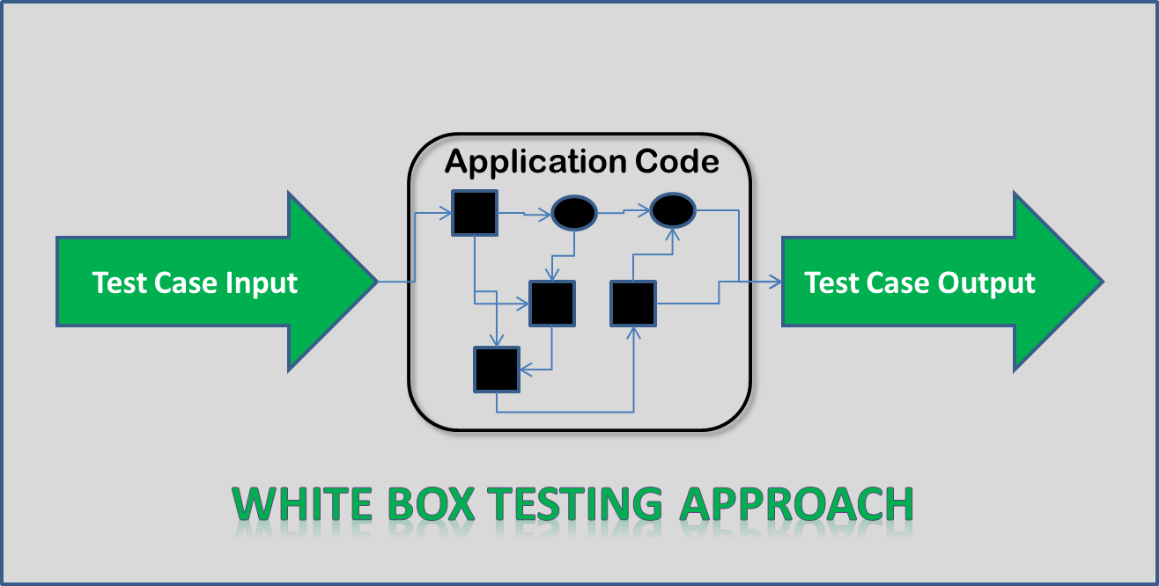

* **White – Box :-**
* Guarantee that all independent paths within a module have been exercised at least once.
* Exercise all logical decisions on their true and false sides.
* Execute all loops at their boundaries and within their operational bounds.
* Exercise internal data structures to ensure their validity.
* **Black Box Testing :-**

Try different inputs and see if we get the correct output:

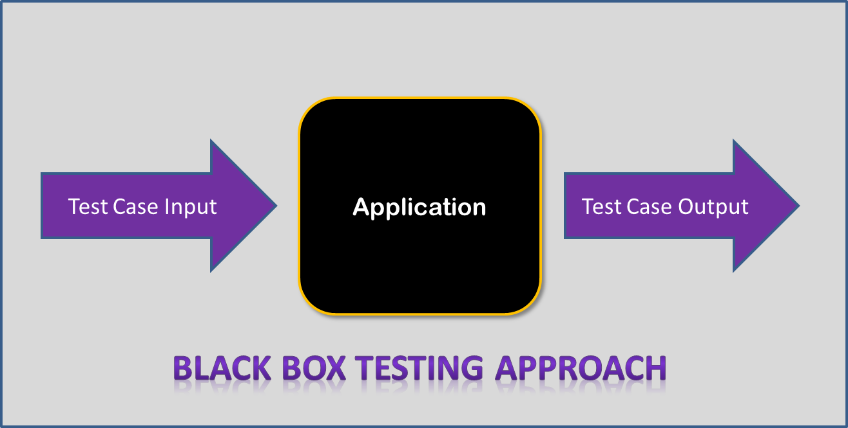

**Black Box:-**

1. Black Interface Errors
2. Errors in Data Structures or external database access.
3. Performance
4. Initialization Errors
5. Boundary value testing.

* **Testing Strategies:-**
* **Unit Testing:-**

Unit testing, also called module or component testing is testing individual software units independently of the other units in the same system. The programmer does this testing. Unit testing is recognized as one of the most efficient ways to reduce the density and proliferation of errors in a software application. Unit testing has been done for each ITEM of the system. We have followed the following procedure to perform unit testing:

* 1. Identified the scenarios for each action in all the screens.
  2. Tested main method in each screen to invoke that screen.
  3. Tested the output for all the possible combination of input values and user actions.
  4. Examine the result of each user action.

**Test Method**

**Identification of the test units:-**

The system “Bookmydoc” has been broadly classified in the following units so that the unit testing can be performed efficiently. The units identified as login module, the main form module contains main menu, in–service module curriculum and evaluation module, working experience module, Bookmydoc module planning and management module, change password module and some other sub-module etc.

The feature of the above identification modules are to be tested individually so that all the errors in those modules can be found and corrected.

Features to be tested:-

* Check incorrect Password.
* Check admin email and password change
* Check Bookmydoc information is correctly entered.
* Check valid character entry
* Check valid numeric value entry
* Check each module attached in main menu module.
* Check each module work well.
* Check all the button work well
* Check each view is worked in efficient manner.
* Check any module cannot operate inefficient manner
* Check database correctly work with related module
* Check Is it work in efficiently in the Bookmydoc.
* Check its error tolerance

**TEST CASES:-**

In different terms and condition, it was find the system “Bookmydoc” is enable to solve the entire problem related to online doctor appointment where people can view & booked appointment online at comfort from their home.

**Is password correct?**

If user Id and password will be correct then a massage as “Login will successful.” will be displayed in the massage box.

All the modules are connected properly with main menu.

This can be displayed on the status bar. Where the entire module can be shown.

**Implementing the test plan in the software with data.:-**

There are two methods are used for implementing the test plan.

* + - 1. **Testing with the dummy data:-** Testing in this way means testing with data which not original or it is dummy. With this method accuracy of the system can be judged according to some extents. If the system is running correctly with this data then it can be inferred that software has been tested successfully.
      2. **Testing with Live data:-** Testing with live data means testing with original data. This means that system is tested with data taken from the actual user. This is very accurate as compared to dummy data. If the system is running correctly with this data then it can be inferred that software tested successfully.

**The Some CASE with Expected Behavior and Observed Behavior:-**

**CASE-1** : Enter wrong User ID and Password.

Expected Behavior : Should prompt “Invalid Password”.

Observed Behavior : Prompt as “Password is not valid”.

**CASE-2** : Enter correct User ID and Password.

Expected Behavior : Should display the fun screen and

Then display the main menu form.

Observed Behavior : Display the Main screen and then

Display the main menu form.

**CASE-3** : Select any menu.

Expected Behavior : Should display the screen and also

Display its content.

Observed Behavior : Display the screen and select any

Option to using it.

**CASE-4** : Without login book appointment on click.

Expected Behavior : Should display login form.

Observed Behavior : Display the login form.

**CASE-5** : User registration.

Expected Behavior : User should be registered.

Observed Behavior : User registered.

**CASE-6** : User login.

Expected Behavior : User should be logged in.

Observed Behavior : User was logged in.

**SCREEN SHOT AND USER MANUAL**

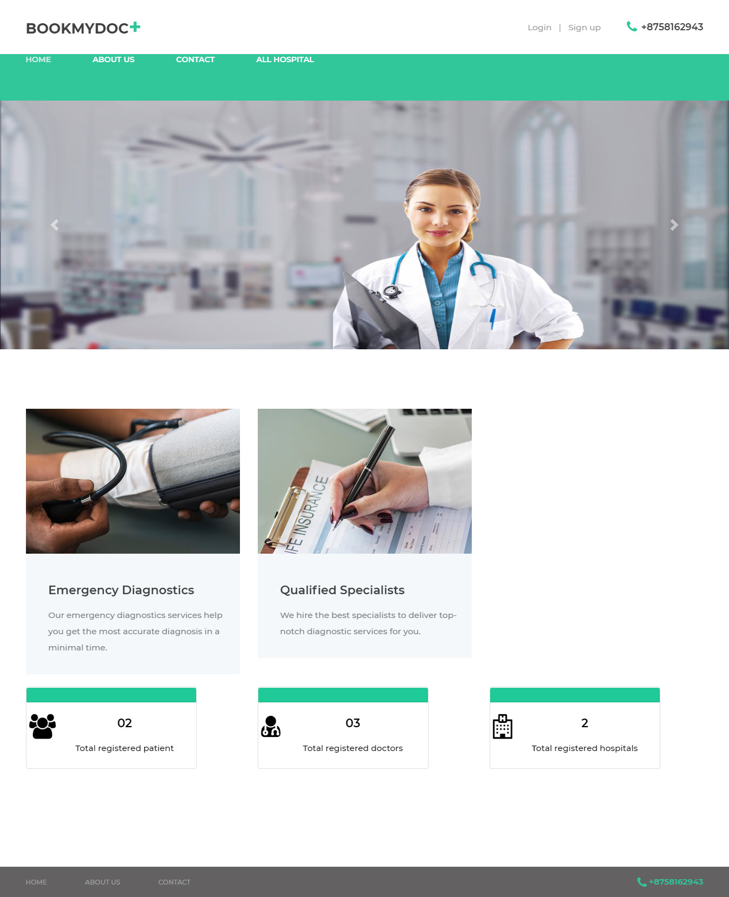**Home:-**

**About Us:-**

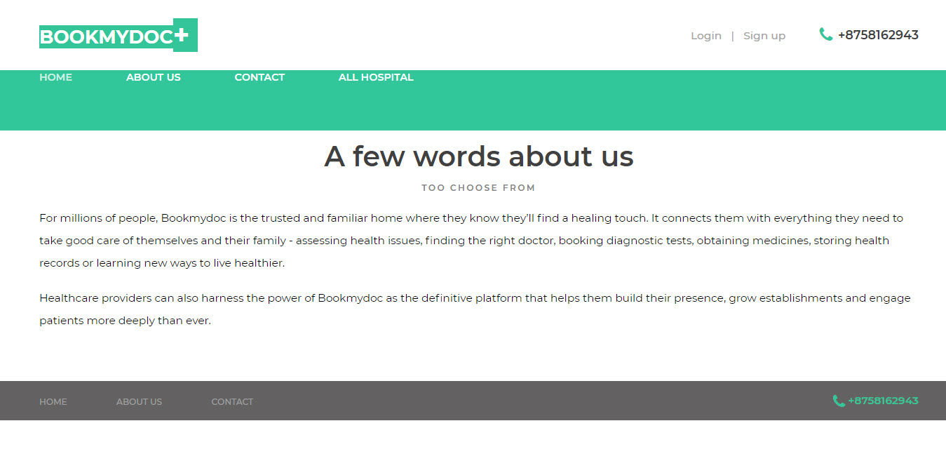

**Contact:-**

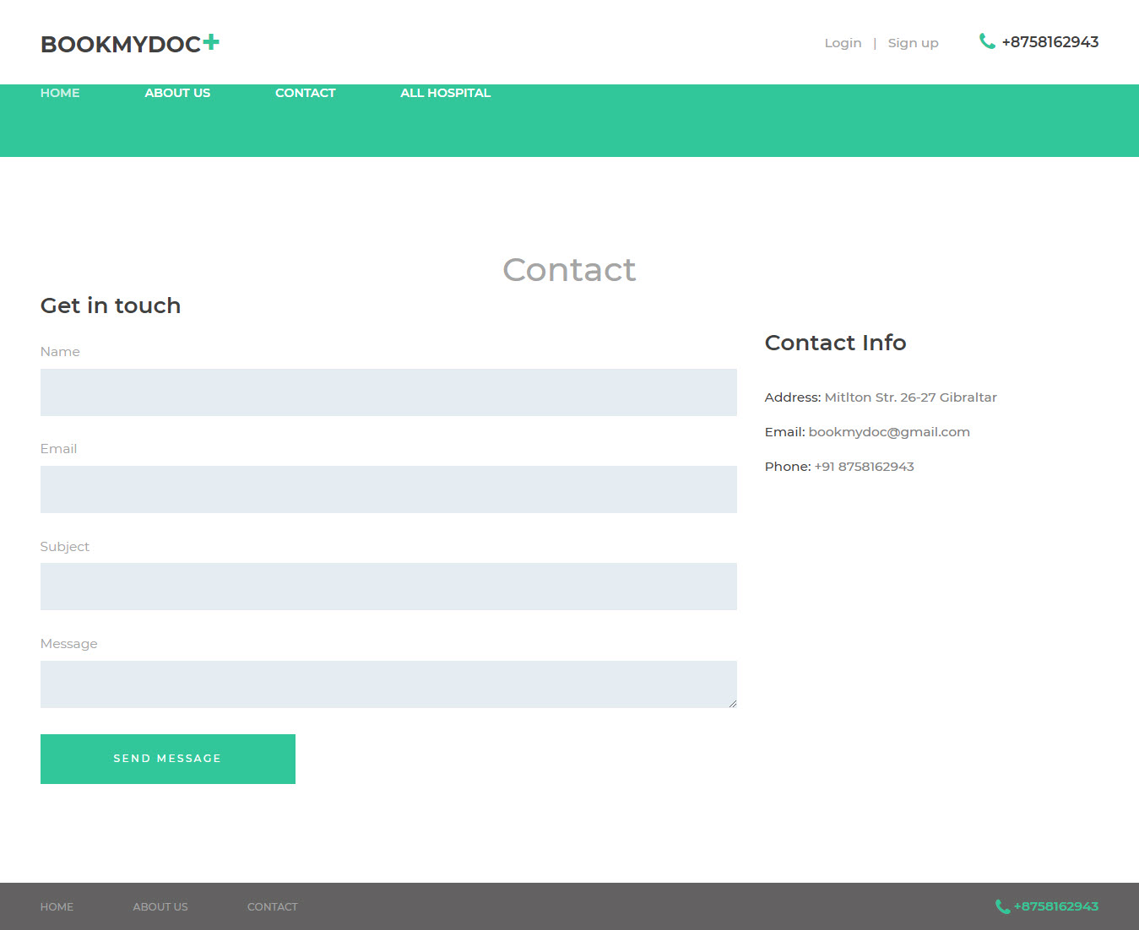

**Login:-**

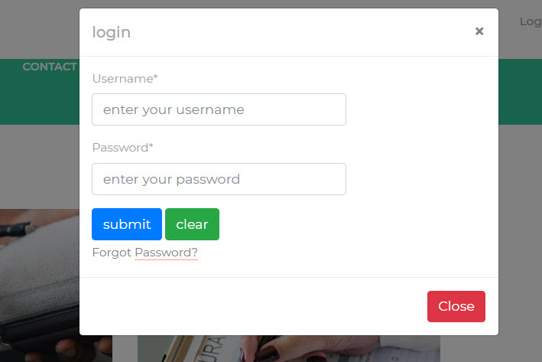

**Register:-**

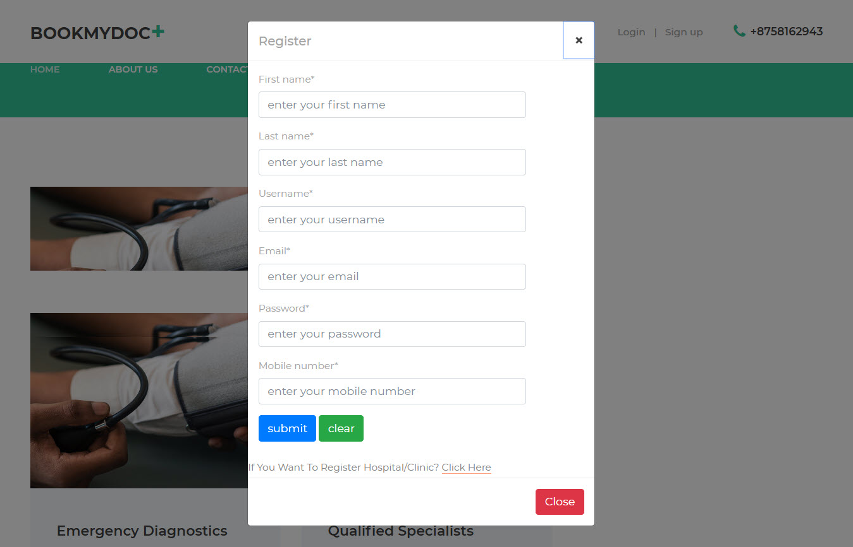

**All Hospital:-**

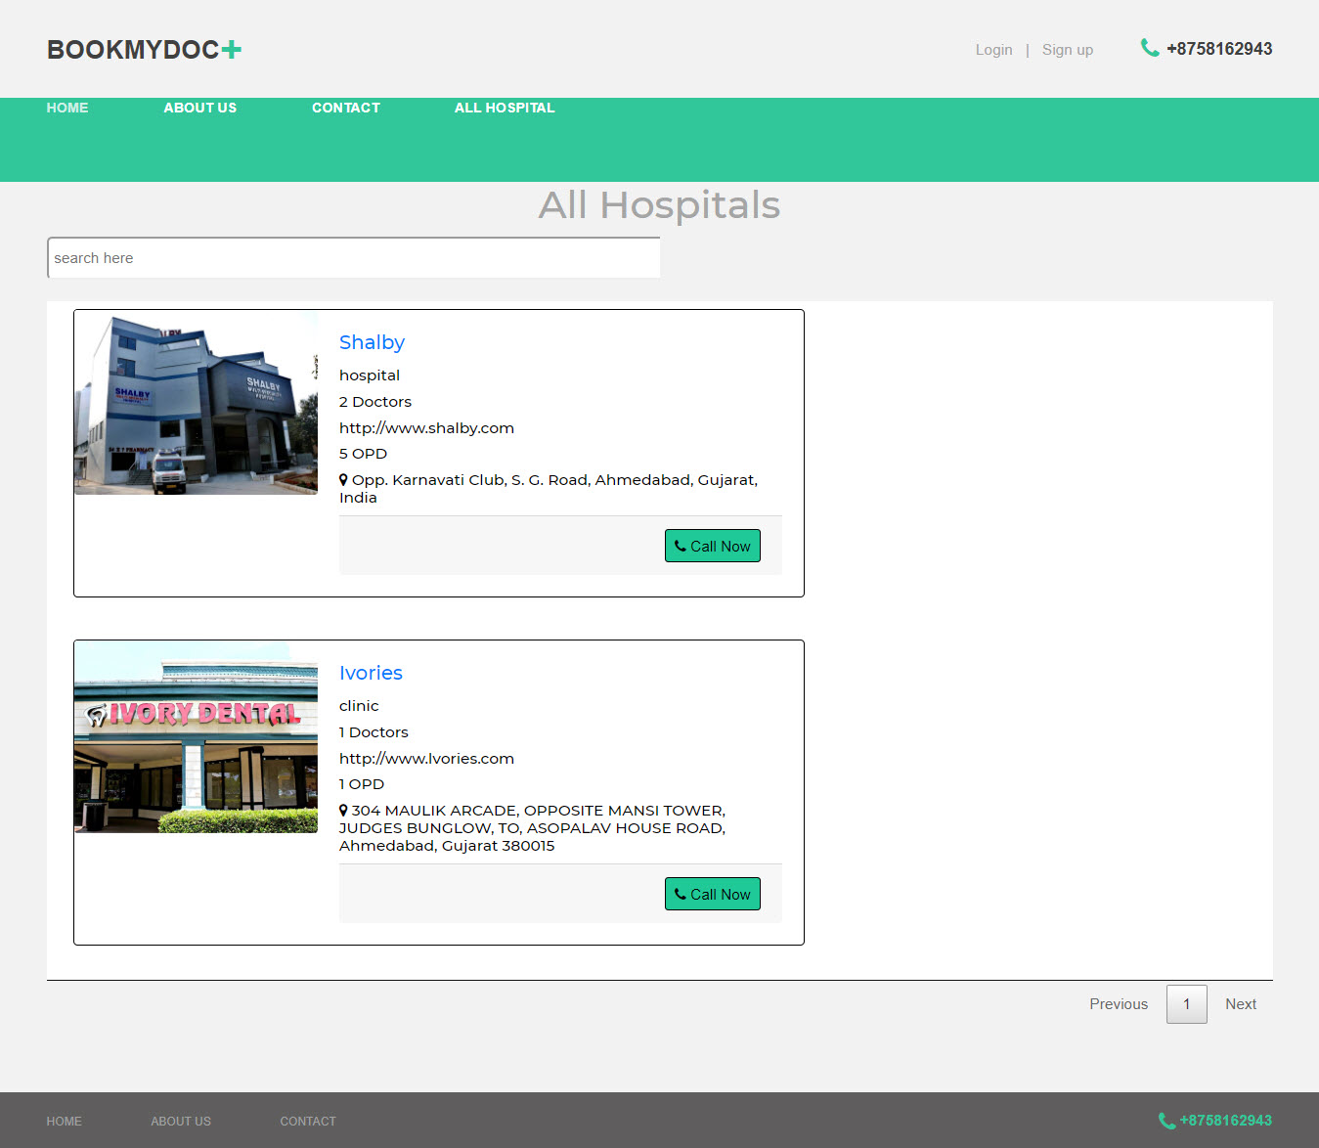

**All Doctor:-**

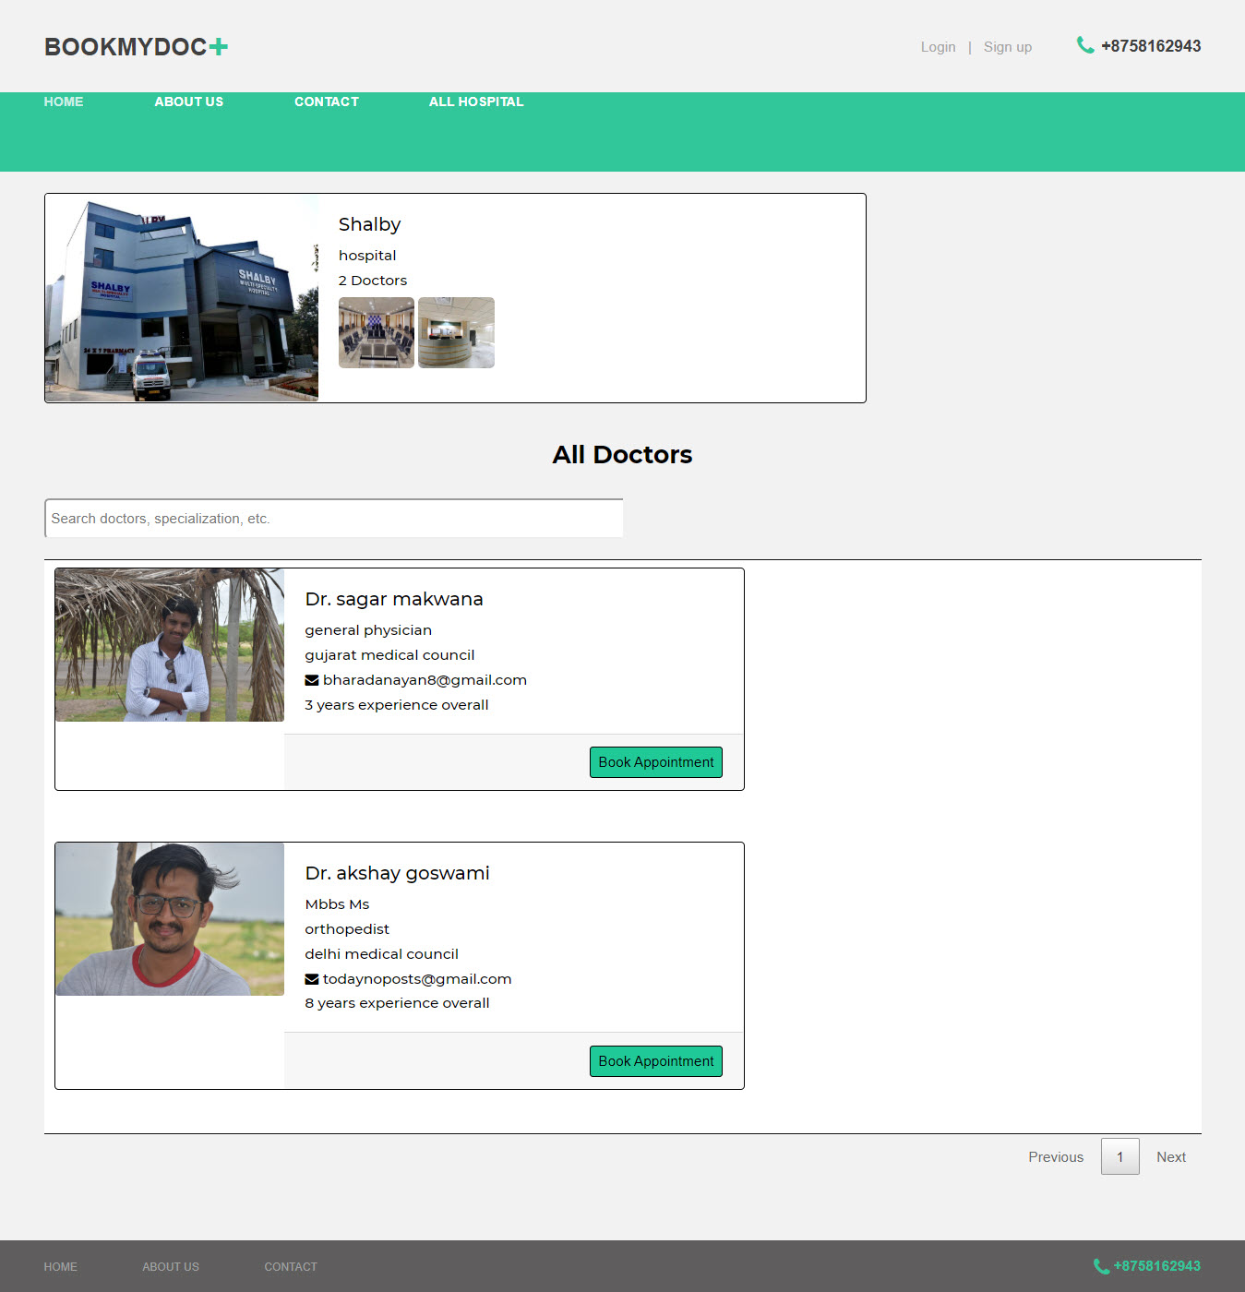

**Book Appointment:-**

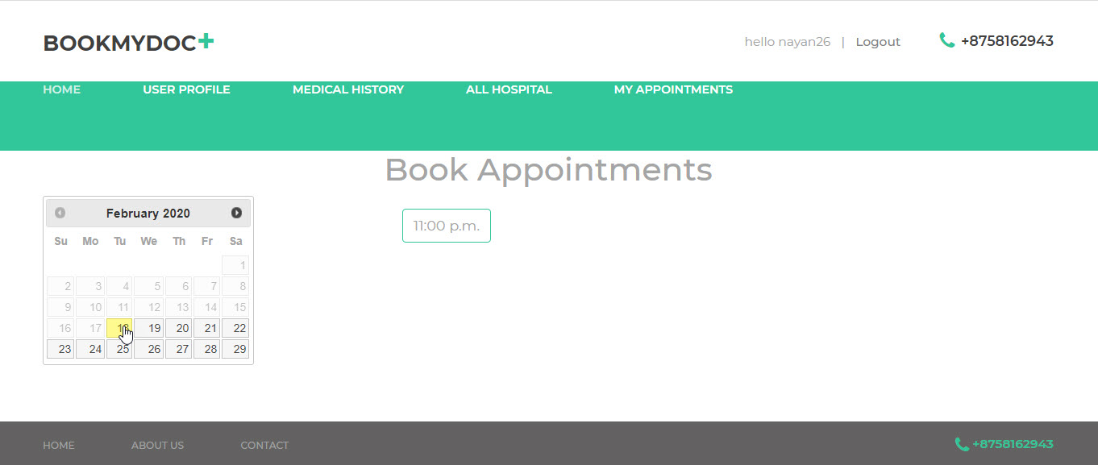

**Hospital Request:-**

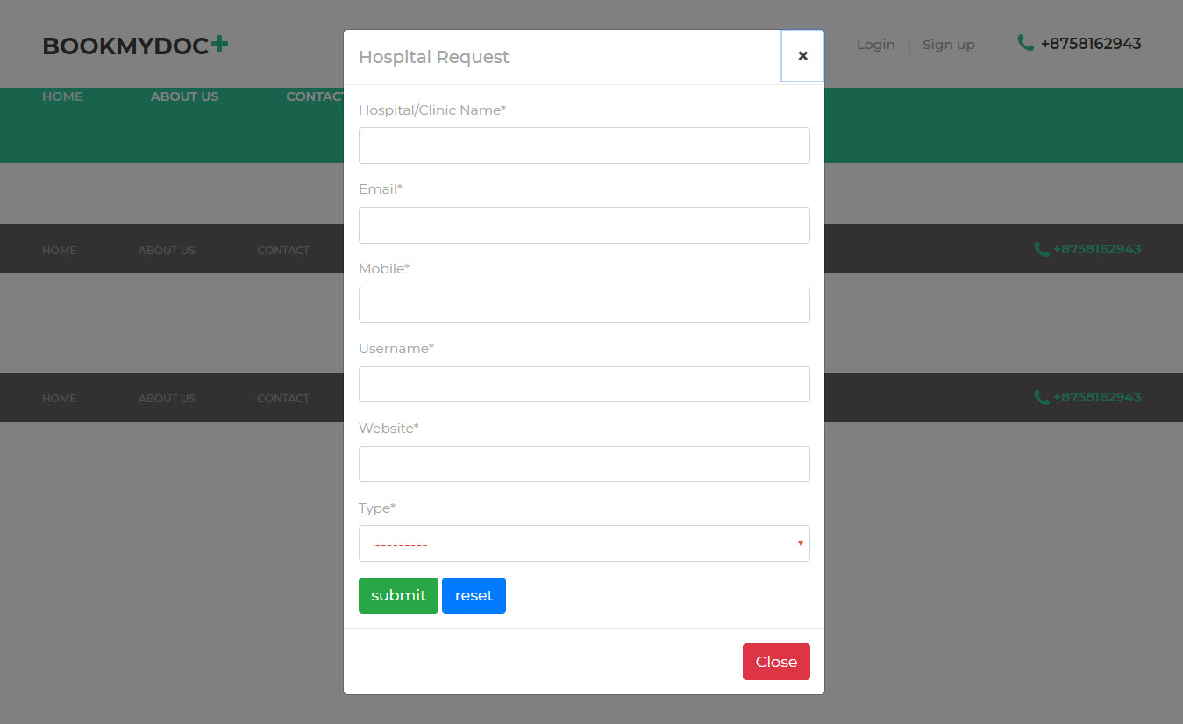

**Forgot Password:-**

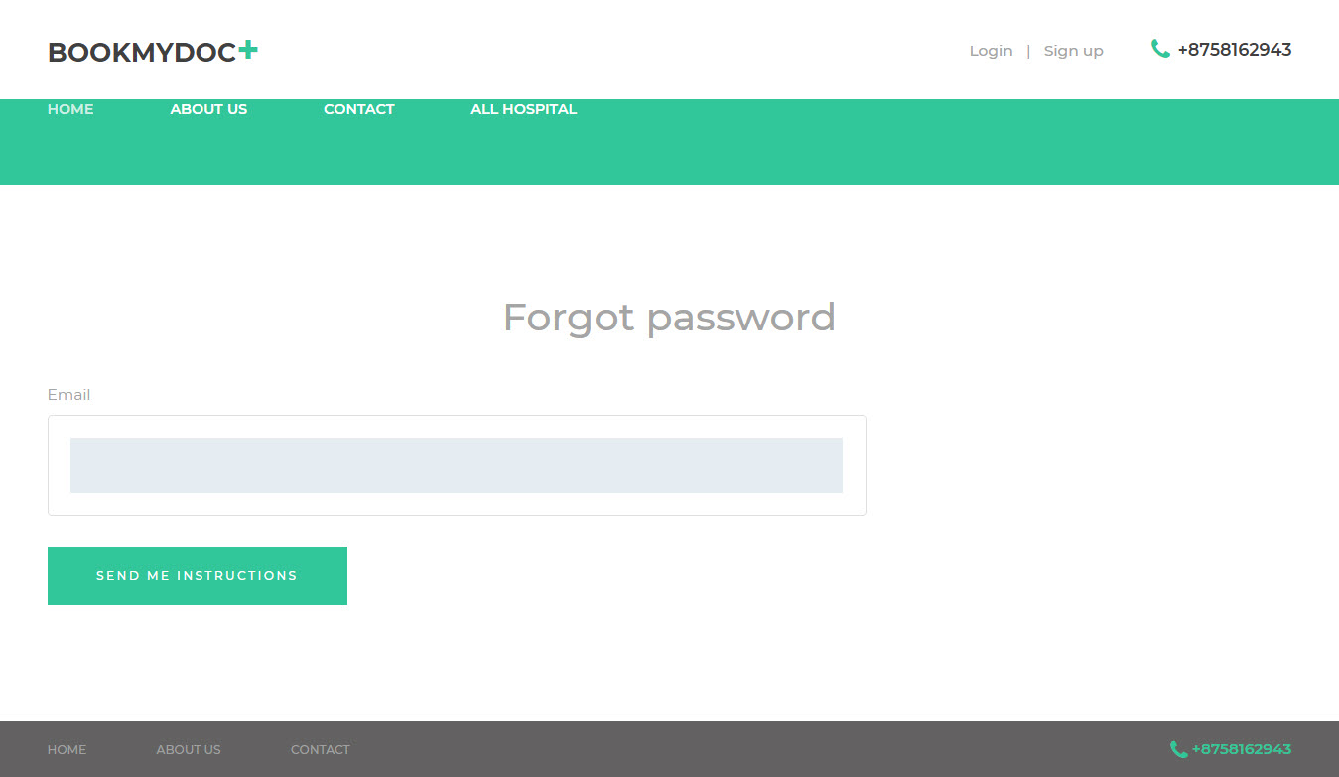

**My Appointment:-**

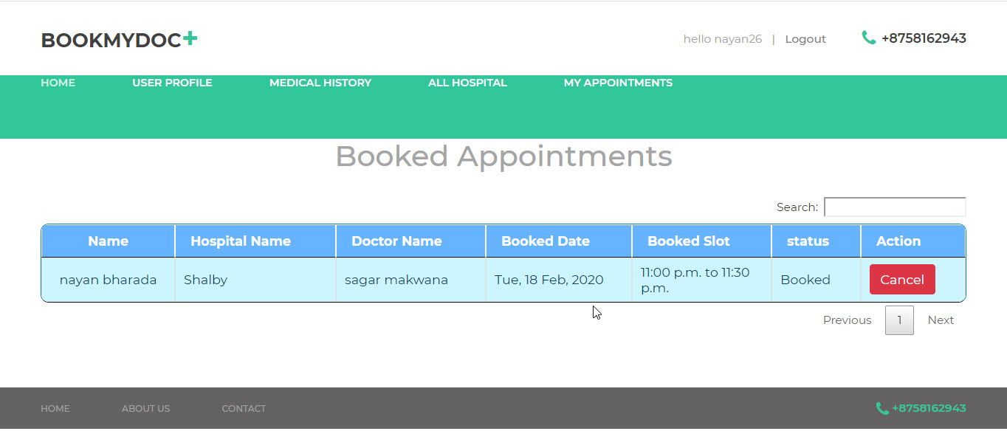

**Hospital Dashboard:-**

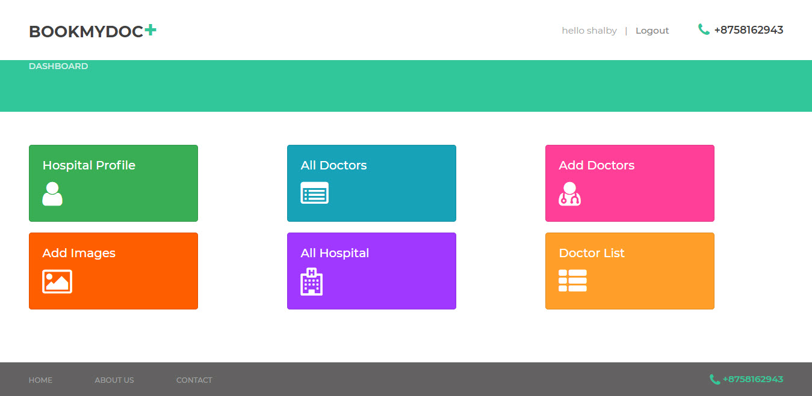

**Add Doctor:-**

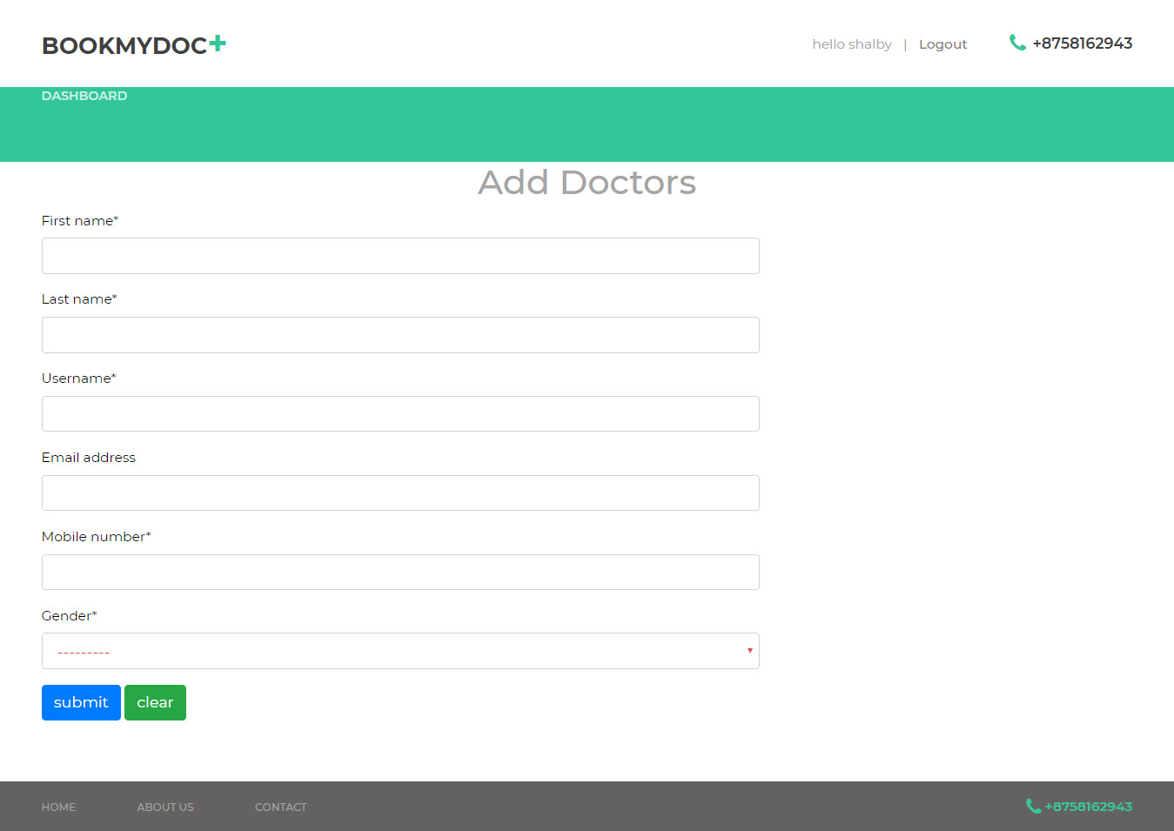

**Hospital Doc:-**

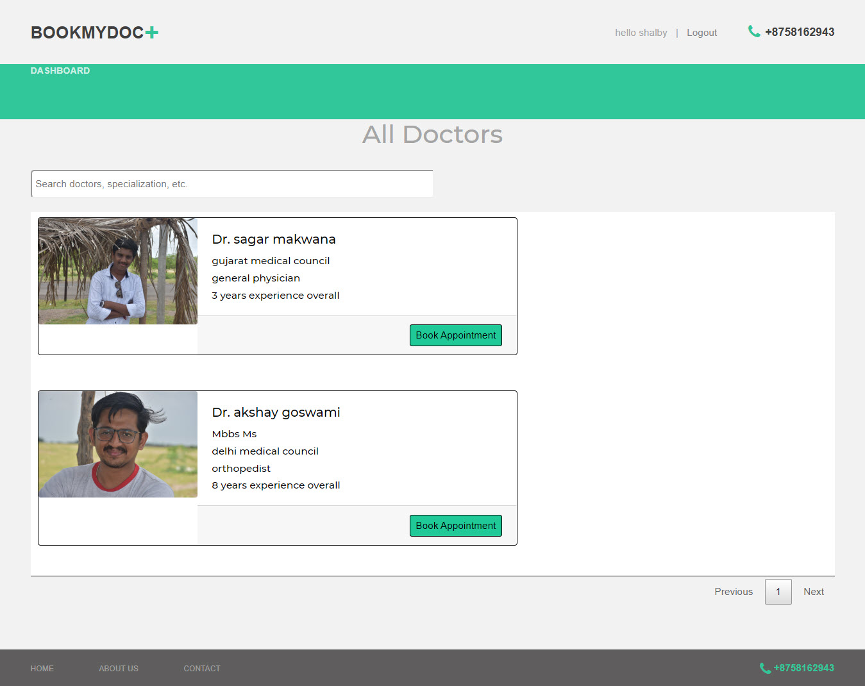

**Add Hospital Image:-**

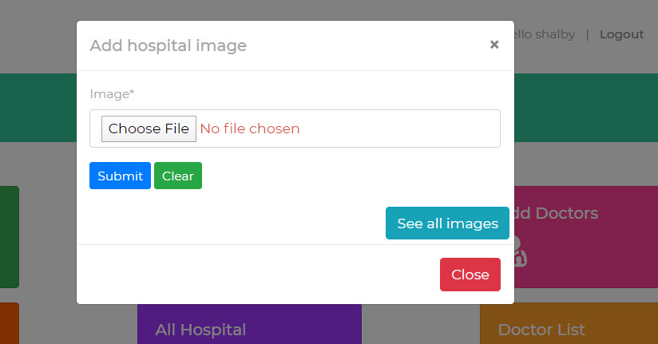

**Hospital Appointment:-**

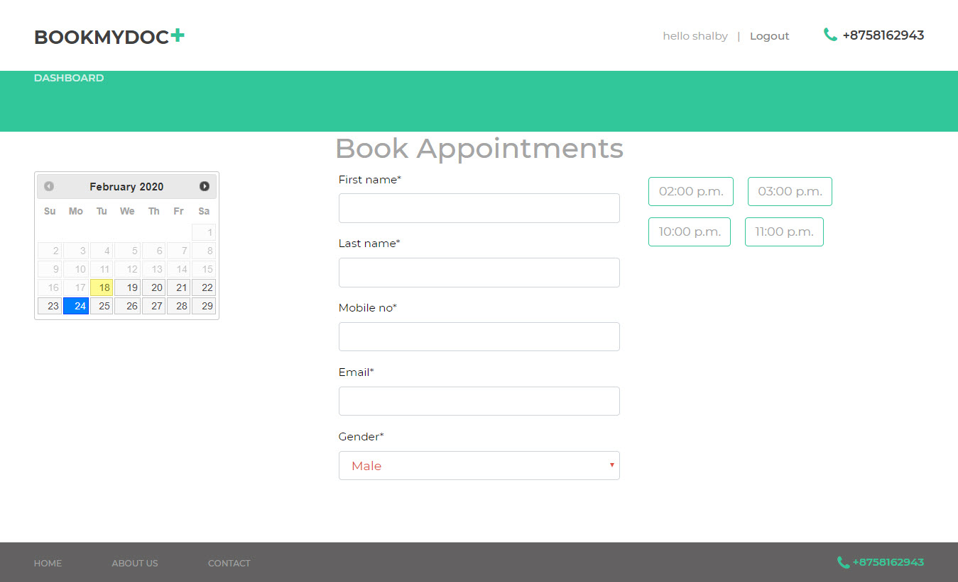

**Manage Hospital Image**:-

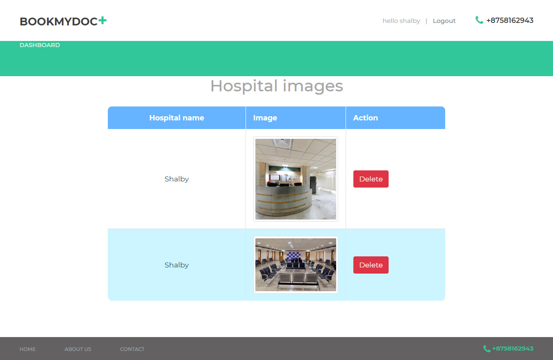

**Manage Doctor:-**

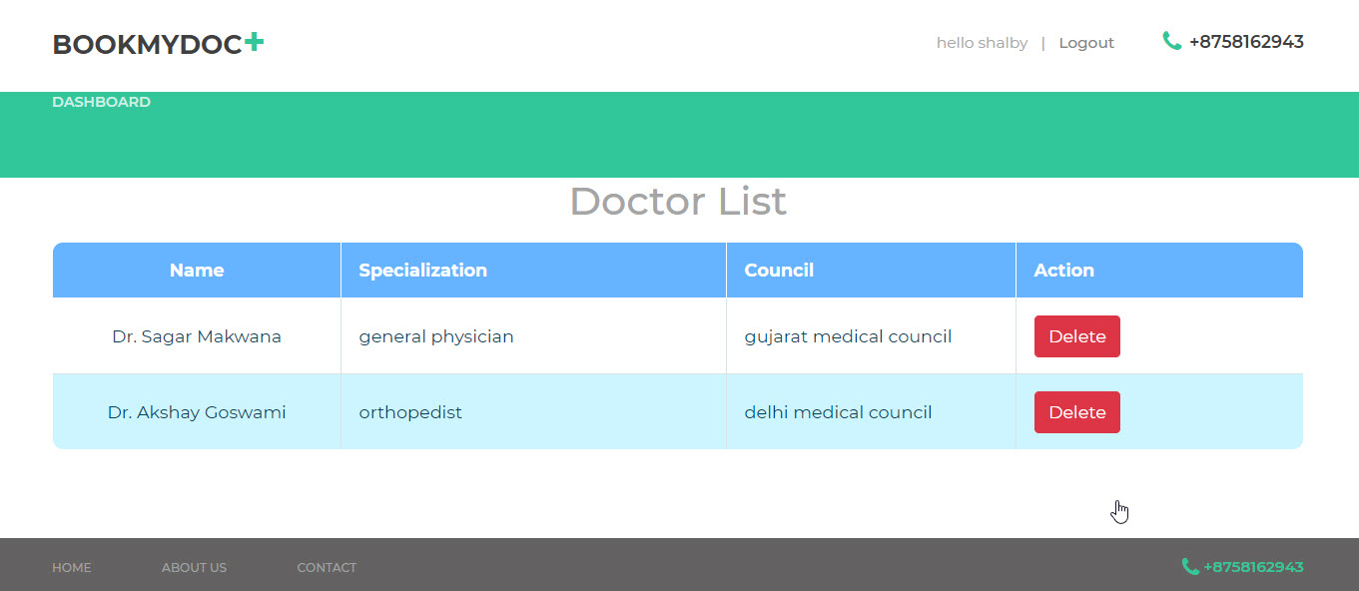

**Hospital Profile:-**

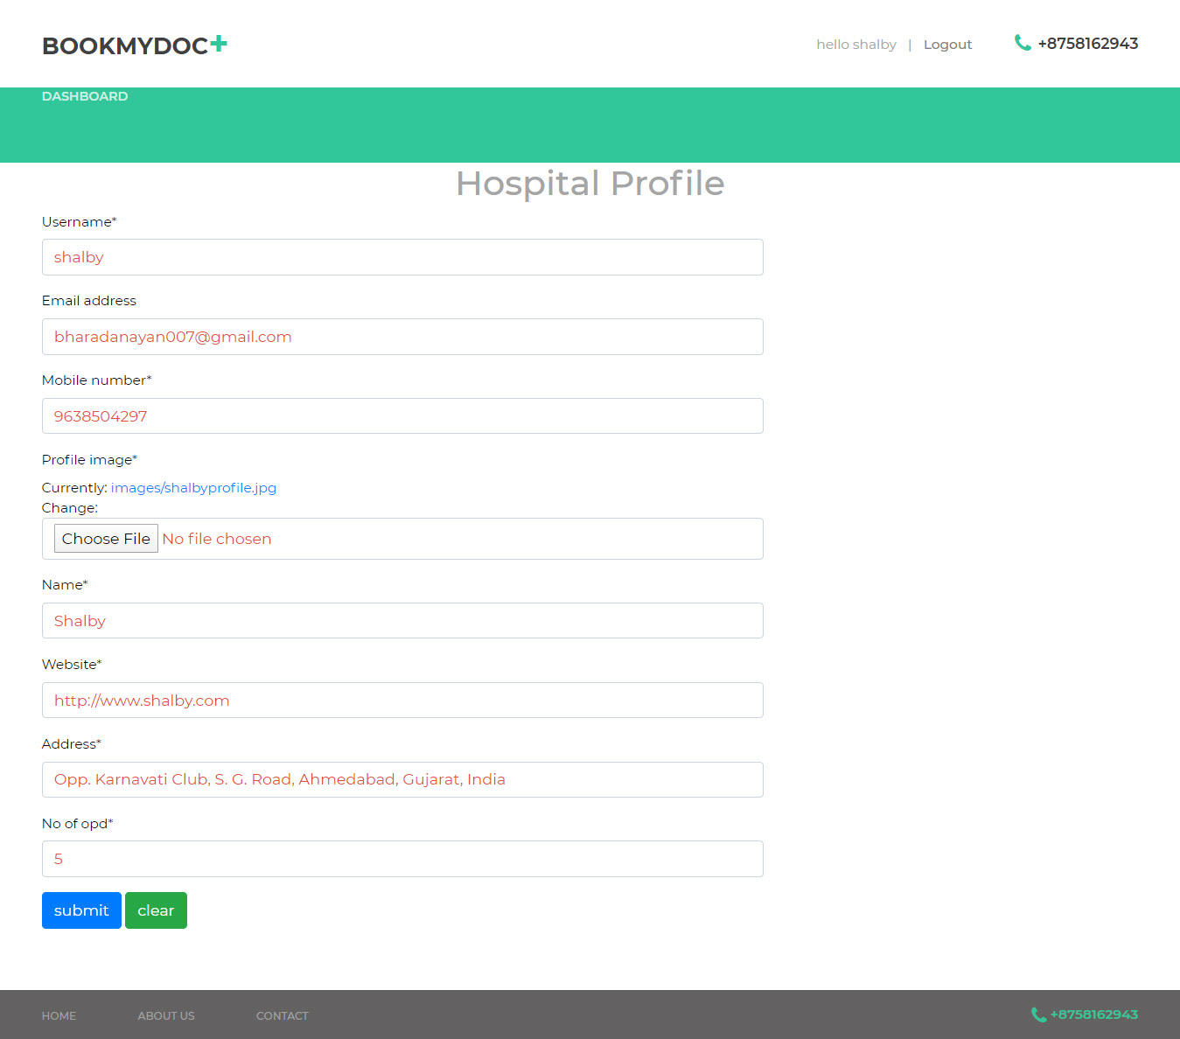

**Doctor Dashboard:-**

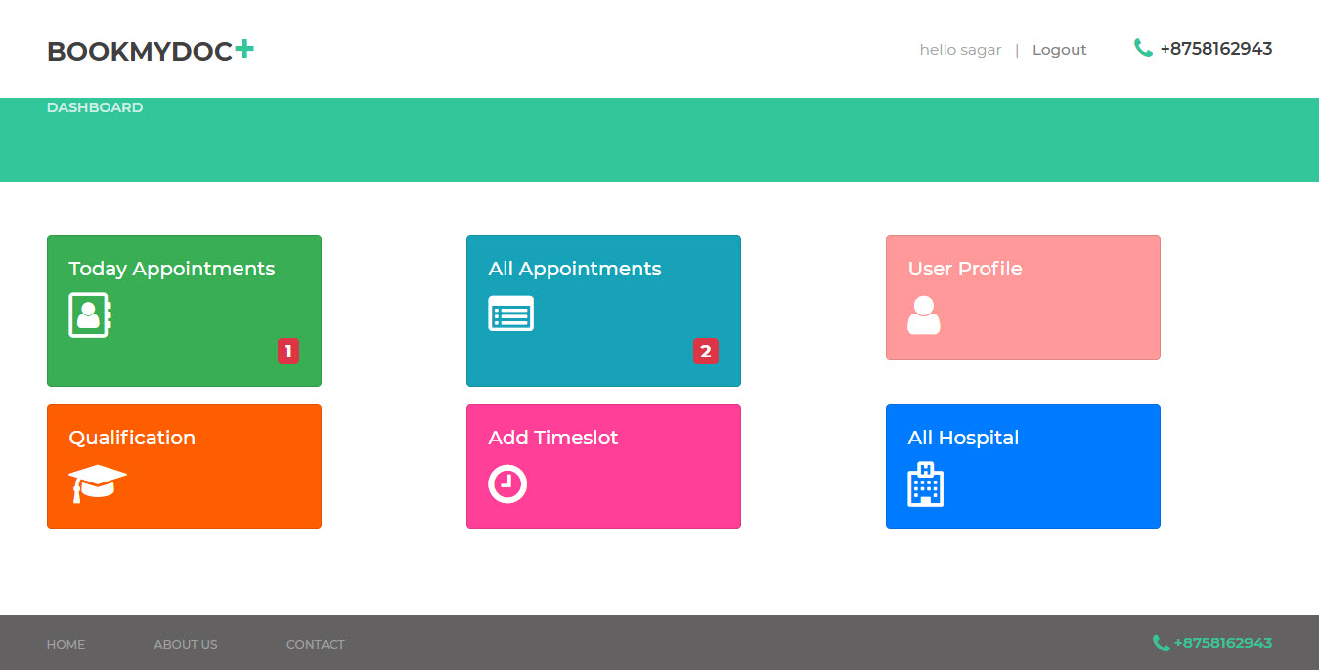

**Manage Doc Qualification:-**

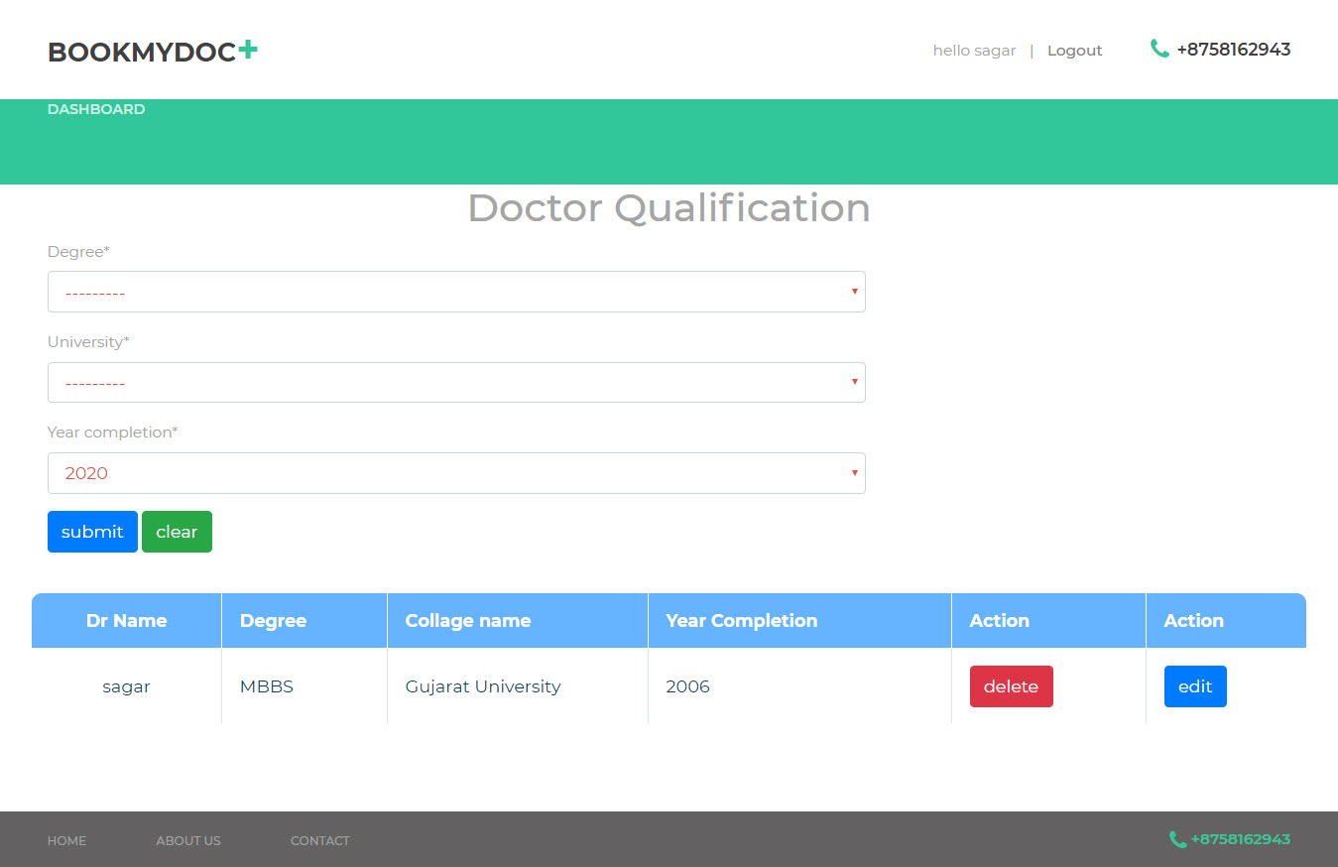

**Doc Profile:-**

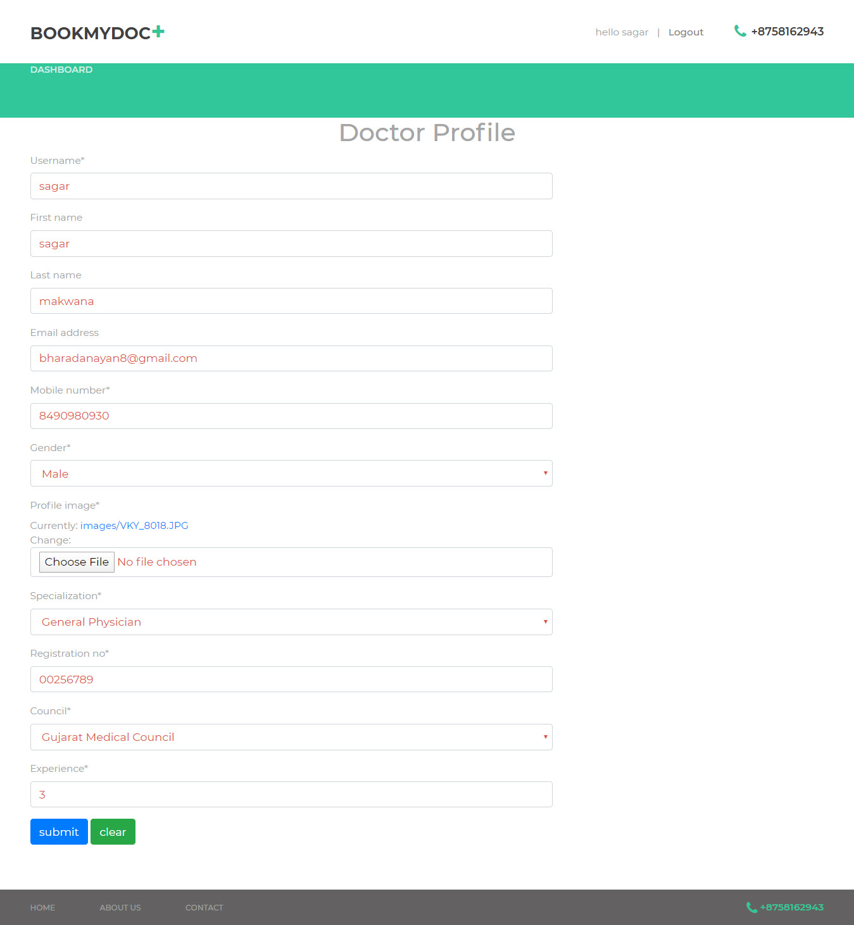

**All Appointment:-**

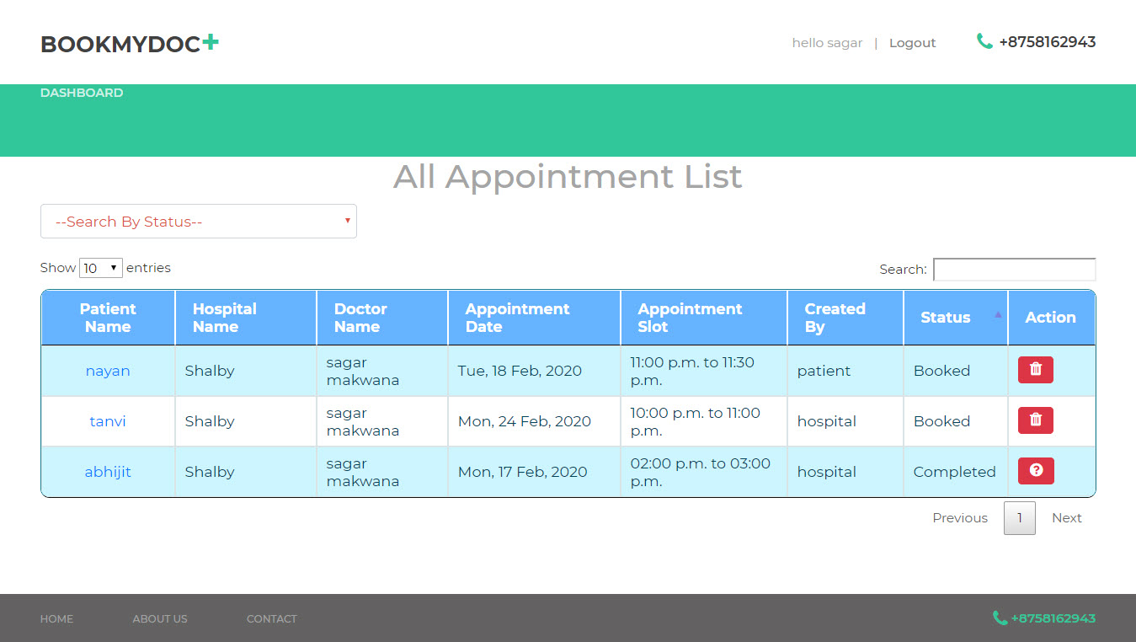

**Today Appointment:-**

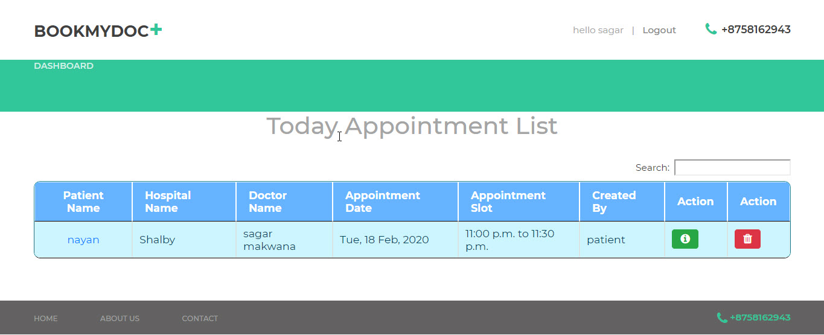

**Manage DoctimeSlot:-**

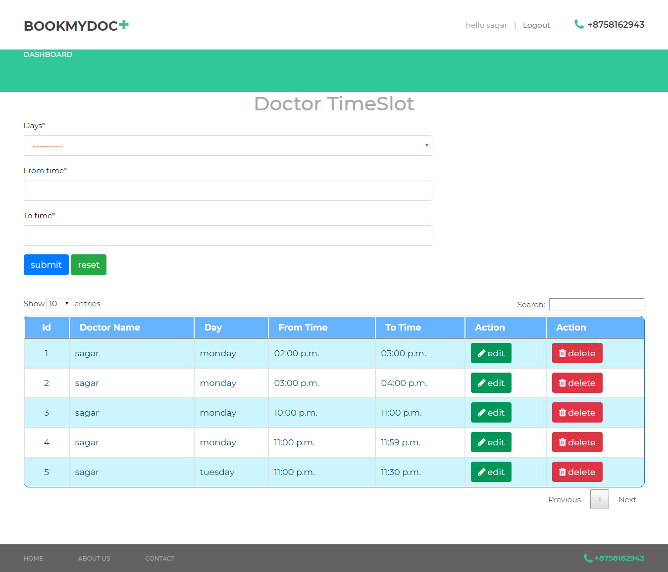

**LIMITATION & FUTURE ENHANCEMENT**

* **Limitation :-**

1. This website is not online.
2. Syntax errors of the Controls.
3. All page images are not dynamic.

* **Future Feature Enhancement:-**

We will make it more user-friendly in future.

We will solve some errors and bugs from our websites.

We will also provide some advanced facilities in near future.

We will make it in user can payment.

We will make it user can specific doctor complain box.

## 

**Bibliography**

The Bibliography contains references to all the documents that were used to develop the software/website.

**Websites:-**

[www.djangogirls.org](http://www.djangogirls.org/)

[www.wikipedia.org](http://www.wikipedia.org/)

[www.djangoproject.com](http://www.djangoproject.com/)

[www.stackoverflow.com](http://www.stackoverflow.com/)

**Search Engine:-**

[www.google.com](http://www.google.com/)